Scratch Advanced- Basic 3D “engine”.

This week we will try to do some basic 3D.

Computer screens are actually 2D – they just have an “X” and a “Y”.

All 3D on a computer is just making things “look” 3D in a 2D world.

How does that happen?

* Smaller things are further away than bigger things, if they look the same!
* Things in front of other things are probably closer than those things
* Far away things tend to be in the middle of the screen
* Faded things are most likely a bit further away

Why is that?

Section on how a camera/eye works..

1. Draw a scene for the background.. green grass, blue sky will work well. Try to get the line in the middle

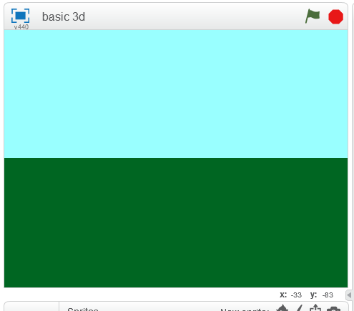

1. Add a Sprite character to the scene – any sprite you like!

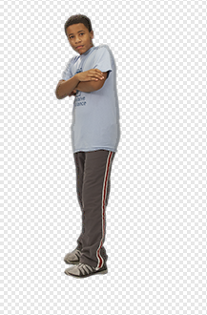

1. Let’s play with clones!

A Clone is a copy of a Sprite. Instead of writing lots of sprites with the same code, it’s easier to just create a clone!

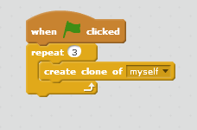

1. Nothing happened? That’s because all the sprites are in the same place! Let’s put them in different places:

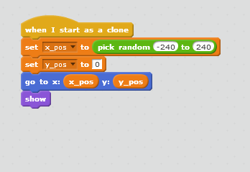

Ok now they are in different places. We want to try putting them at different DISTANCES to each other  
  
The formula for Perspective is:

Perspective = focal length / distance + focal length

1. Change the sprite so that it changes size based on the perspective:

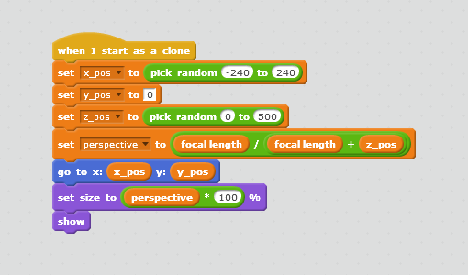

Great! Close sprites and far sprites! Or at least big and small!

Spot any problems?

* Small sprites in front of big cats ☹
* Everything is along the center. That’s not how things look remember?

Final Engine Code

